PROGRAM 1 CODING:
import tensorflow as tf
from tensorflow import keras
import matplotlib.pyplot as plt
import numpy as np
# Load MNIST dataset (grayscale images)
(x_train, y_train), (x_test, y_test) = keras.datasets.mnist.load_data()
# Normalize
x_train = x_train / 255.0
x_test = x_test / 255.0
# Reshape
x_train = x_train.reshape(-1, 28*28)
x_test = x_test.reshape(-1, 28*28)
# Build model
model = keras.Sequential([
keras.layers.Dense(128, activation='relu', input_shape=(784,)),
keras.layers.Dense(64, activation='relu'),
keras.layers.Dense(10, activation='softmax')
])
# Compile model
model.compile(optimizer='adam',
loss='sparse_categorical_crossentropy', metrics=['accuracy'])
# Train
model.fit(x_train, y_train, epochs=5)
# Evaluate
test_loss, test_acc = model.evaluate(x_test, y_test)
print("Test Accuracy:", test_acc)
# Predict and display first 5 test images
predictions = model.predict(x_test[:5])
for i in range(5):
print("Predicted class:", np.argmax(predictions[i]))
plt.imshow(x_test[i].reshape(28, 28), cmap='gray')
plt.show()
OUTPUT:
Test Accuracy: 0.9768000245094299
1/1 ━━━━━━━━━━━━━━━━━━━━ 0s 78ms/step
Predicted class: 7
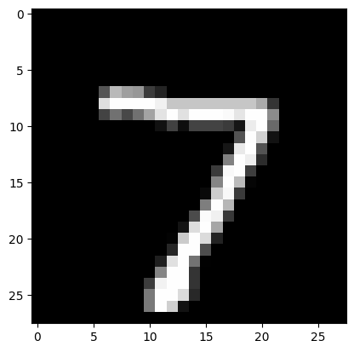
Predicted class: 2
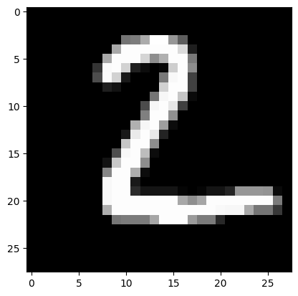
Predicted class: 1
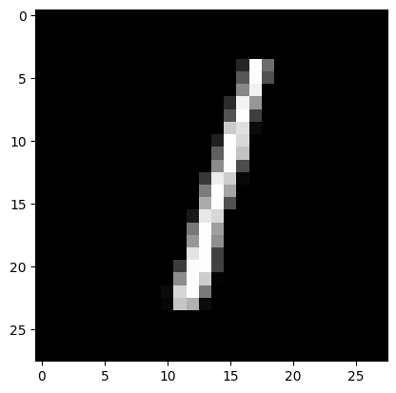
Predicted class: 0
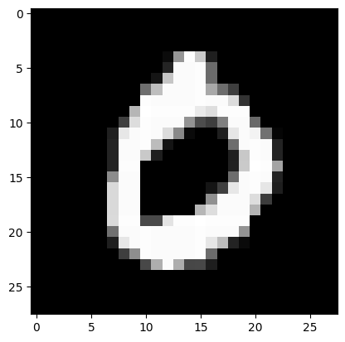
Predicted class: 4
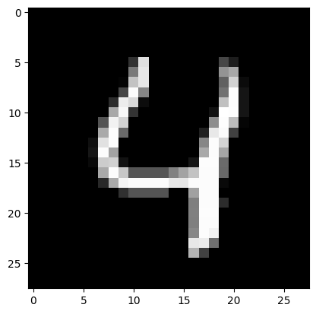
PROGRAM 2 CODING:
# Import necessary libraries
import numpy as np
from sklearn.linear_model import Perceptron
import matplotlib.pyplot as plt
# Generate a linearly separable binary dataset
# Class 0: centered at (6, 6)
# Class 1: centered at (2, 2)
np.random.seed(42) # For reproducibility
class_0 = np.random.randn(50, 2) + [6, 6]
class_1 = np.random.randn(50, 2) + [2, 2]
# Combine data and create labels
X = np.vstack((class_0, class_1))
y = np.hstack((np.zeros(50), np.ones(50)))
# Train a Perceptron model
model = Perceptron(max_iter=1000, tol=1e-3)
model.fit(X, y)
# Print model coefficients and intercept
print("Weights:", model.coef_)
print("Bias:", model.intercept_)
# Plot the dataset
plt.scatter(X[:50, 0], X[:50, 1], color='red', label='Class 0')
plt.scatter(X[50:, 0], X[50:, 1], color='blue', label='Class 1')
# Decision boundary: w0*x + w1*y + b = 0
x_vals = np.linspace(X[:, 0].min(), X[:, 0].max(), 100)
y_vals = -(model.coef_[0][0] * x_vals + model.intercept_[0]) / model.coef_[0][1]
plt.plot(x_vals, y_vals, color='green', label='Decision Boundary')
plt.legend()
plt.xlabel("Feature 1")
plt.ylabel("Feature 2")
plt.title("Perceptron Classification")
plt.show()
OUTPUT:
Weights: [[-1.46846929 -2.62906917]]
Bias: [19.]
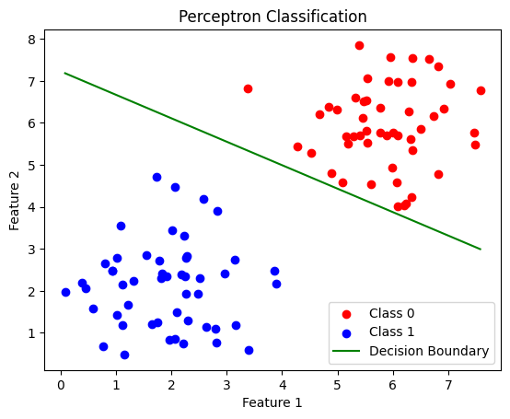
PROGRAM 3 CODING:
import numpy as np
# Activation
sig = lambda x: 1/(1+np.exp(-x))
dsig = lambda x: x*(1-x)
# Data (XOR)
X = np.array([[0,0],[0,1],[1,0],[1,1]])
y = np.array([[0],[1],[1],[0]])
np.random.seed(1)
# Weights
W1 = np.random.randn(2,4)
W2 = np.random.randn(4,1)
lr = 0.1
# Training
for i in range(5000):
h = sig(X @ W1)
o = sig(h @ W2)
d2 = (y - o) * dsig(o)
d1 = d2 @ W2.T * dsig(h)
W2 += h.T @ d2 * lr
W1 += X.T @ d1 * lr
if i % 1000 == 0:
print(f"Epoch {i}, Loss: {np.mean((y-o)**2):.6f}")
# Output
print("\nFinal Predictions:")
print(o.round(3))
OUTPUT:
Final Predictions:
[[0.143]
[0.874]
[0.859]
[0.149]]
PROGRAM 4 CODING:
import numpy as np
from tensorflow.keras.datasets import mnist
from tensorflow.keras.models import Sequential
from tensorflow.keras.layers import Dense, Flatten
from tensorflow.keras.utils import to_categorical
# Load dataset
(x_train, y_train), (x_test, y_test) = mnist.load_data()
# Normalize & preprocess
x_train, x_test = x_train/255.0, x_test/255.0
y_train, y_test = to_categorical(y_train), to_categorical(y_test)
# Deep Feed Forward Model
model = Sequential([
Flatten(input_shape=(28,28)),
Dense(128, activation='relu'),
Dense(64, activation='relu'),
Dense(10, activation='softmax')
])
model.compile(optimizer='adam', loss='categorical_crossentropy', metrics=['accuracy'])
# Training
model.fit(x_train, y_train, epochs=3, verbose=0)
# Evaluation
loss, acc = model.evaluate(x_test, y_test, verbose=0)
# Prediction
pred = model.predict(x_test[:5]).argmax(axis=1)
print("\n===== OUTPUT =====")
print("Test Accuracy :", acc)
print("Predicted Classes :", pred)
print("Actual Classes :", np.argmax(y_test[:5], axis=1))
OUTPUT:
===== OUTPUT =====
Test Accuracy : 0.9747999906539917
Predicted Classes : [7 2 1 0 4]
Actual Classes : [7 2 1 0 4]
PROGRAM 5 CODING:
import numpy as np
from tensorflow.keras.datasets import mnist
from tensorflow.keras.models import Sequential
from tensorflow.keras.layers import Conv2D, MaxPooling2D, Flatten, Dense
(x_train, y_train), (x_test, y_test) = mnist.load_data()
# Preprocessing
x_train = x_train.reshape(-1, 28, 28, 1) / 255.0
x_test = x_test.reshape(-1, 28, 28, 1) / 255.0
# CNN Model
model = Sequential([
Conv2D(32, (3,3), activation='relu', input_shape=(28,28,1)),
MaxPooling2D((2,2)),
Conv2D(64, (3,3), activation='relu'),
MaxPooling2D((2,2)),
Flatten(),
Dense(64, activation='relu'),
Dense(10, activation='softmax')
])
# Compile
model.compile(optimizer='adam',
loss='sparse_categorical_crossentropy',
metrics=['accuracy']
model.fit(x_train, y_train, epochs=2, verbose=0)
loss, acc = model.evaluate(x_test, y_test, verbose=0)
pred = model.predict(x_test[:5]).argmax(axis=1)
print("\n=========== OUTPUT ===========")
print("Test Accuracy :", acc)
print("Predicted Digits :", pred)
print("Actual Digits :", y_test[:5])
OUTPUT:
=========== OUTPUT ===========
Test Accuracy : 0.98580002784729
Predicted Digits : [7 2 1 0 4]
Actual Digits : [7 2 1 0 4]
PROGRAM 6 CODING:
import numpy as np
from tensorflow.keras.models import Sequential
from tensorflow.keras.layers import SimpleRNN, Dense
# Dataset
X = np.array([[1,2,3,4,5]])
y = np.array([6])
X = X.reshape((1,5,1))
# Model
model = Sequential()
model.add(SimpleRNN(10, activation='relu', input_shape=(5,1)))
model.add(Dense(1))
model.compile(optimizer='adam', loss='mse')
# Training
model.fit(X, y, epochs=300, verbose=0)
# Prediction
print("Predicted next number:", model.predict(X))
OUTPUT:
1/1 ━━━━━━━━━━━━━━━━━━━━ 0s 259ms/step
Predicted next number: [[6.0000005]]
PROGRAM 7 CODING:
from tensorflow.keras.applications import MobileNetV2
from tensorflow.keras.models import Sequential
from tensorflow.keras.layers import Dense, Flatten
from tensorflow.keras.datasets import cifar10
(x_train, y_train), (x_test, y_test) = cifar10.load_data()
base_model = MobileNetV2(weights='imagenet', include_top=False, input_shape=(32,32,3))
base_model.trainable = False
model = Sequential([
base_model,
Flatten(),
Dense(10, activation='softmax')
])
model.compile(optimizer='adam', loss='sparse_categorical_crossentropy', metrics=['accuracy'])
model.fit(x_train, y_train, epochs=1)
OUTPUT:
9406464/9406464 ━━━━━━━━━━━━━━━━━━━━ 0s 0us/step
1563/1563 ━━━━━━━━━━━━━━━━━━━━ 63s 37ms/step - accuracy: 0.1749 - loss: 2.2182
PROGRAM 8 CODING:
from tensorflow.keras.datasets import mnist
from tensorflow.keras.models import Sequential
from tensorflow.keras.layers import Dense, Flatten, Reshape
(x_train,_),(x_test,_) = mnist.load_data()
x_train = x_train/255.0
x_test = x_test/255.0
model = Sequential([
Flatten(input_shape=(28,28)),
Dense(64, activation='relu'),
Dense(784, activation='sigmoid'),
Reshape((28,28))
])
model.compile(optimizer='adam', loss='binary_crossentropy')
model.fit(x_train, x_train, epochs=3)
OUTPUT:
Epoch 1/3
1875/1875 ━━━━━━━━━━━━━━━━━━━━ 10s 5ms/step - loss: 0.1962
Epoch 2/3
1875/1875 ━━━━━━━━━━━━━━━━━━━━ 9s 5ms/step - loss: 0.0868
Epoch 3/3
1875/1875 ━━━━━━━━━━━━━━━━━━━━ 8s 4ms/step - loss: 0.0780
PROGRAM 9 CODING:
from tensorflow.keras.preprocessing.image import ImageDataGenerator
from tensorflow.keras.datasets import mnist
import numpy as np
import matplotlib.pyplot as plt
# Load dataset
(x_train, _), (_, _) = mnist.load_data()
# Reshape
x_train = x_train.reshape(-1, 28, 28, 1)
# Create data generator
datagen = ImageDataGenerator(rotation_range=20, zoom_range=0.2)
# Generate and display augmented image
for batch in datagen.flow(x_train[:1], batch_size=1):
plt.imshow(batch[0].reshape(28, 28), cmap='gray')
plt.title("Augmented Image")
plt.axis('off')
plt.show()
break
OUTPUT:
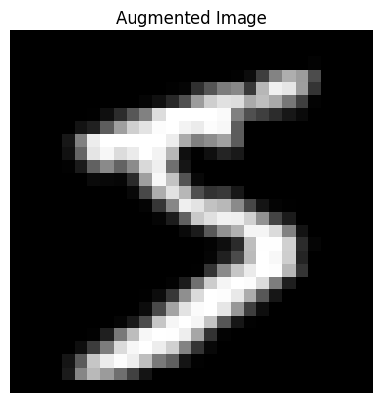
PROGRAM 10 CODING:
from tensorflow.keras.datasets import mnist
from tensorflow.keras.models import Sequential
from tensorflow.keras.layers import Conv2D, AveragePooling2D, Flatten, Dense
# Load dataset
(x_train, y_train), (x_test, y_test) = mnist.load_data()
# Reshape and normalize
x_train = x_train.reshape(-1, 28, 28, 1) / 255.0
x_test = x_test.reshape(-1, 28, 28, 1) / 255.0
# Build CNN model
model = Sequential([
Conv2D(6, kernel_size=5, activation='relu', input_shape=(28, 28, 1)),
AveragePooling2D(pool_size=(2, 2)),
Conv2D(16, kernel_size=5, activation='relu'),
AveragePooling2D(pool_size=(2, 2)),
Flatten(),
Dense(120, activation='relu'),
Dense(10, activation='softmax')
])
# Compile model
model.compile(optimizer='adam',
loss='sparse_categorical_crossentropy',
metrics=['accuracy'])
# Train model
model.fit(x_train, y_train, epochs=1, validation_data=(x_test, y_test))
# Evaluate
test_loss, test_acc = model.evaluate(x_test, y_test)
print("Test Accuracy:", test_acc)
OUTPUT:
1875/1875 ━━━━━━━━━━━━━━━━━━━━ 34s 17ms/step - accuracy: 0.8410 - loss: 0.5124 - val_accuracy: 0.9712 - val_loss: 0.0887
313/313 ━━━━━━━━━━━━━━━━━━━━ 2s 6ms/step - accuracy: 0.9644 - loss: 0.1058
Test Accuracy: 0.9711999893188477
PROGRAM 11 CODING:
import numpy as np
from tensorflow.keras.models import Sequential
from tensorflow.keras.layers import Dense
from tensorflow.keras.optimizers import Adam
from sklearn.model_selection import train_test_split
# Dataset
X = np.array([[1],[2],[3],[4],[5],[6],[7],[8]])
y = np.array([2,4,6,8,10,12,14,16])
# Train-test split
X_train, X_test, y_train, y_test = train_test_split(
X, y, test_size=0.25, random_state=42)
# Different learning rates
learning_rates = [0.1, 0.01, 0.001]
for lr in learning_rates:
print("\nTraining with Learning Rate =", lr)
model = Sequential()
model.add(Dense(8, activation='relu', input_shape=(1,)))
model.add(Dense(1))
optimizer = Adam(learning_rate=lr)
model.compile(optimizer=optimizer, loss='mse', metrics=['mae'])
model.fit(X_train, y_train, epochs=100, verbose=0)
loss, mae = model.evaluate(X_test, y_test, verbose=0)
print("Test MAE:", mae)
OUTPUT:
Training with Learning Rate = 0.1
Test MAE: 0.011225700378417969
Training with Learning Rate = 0.01
Test MAE: 0.20060038566589355
Training with Learning Rate = 0.001
Test MAE: 7.165890693664551
PROGRAM 12 CODING:
import numpy as np
from tensorflow.keras.models import Sequential, load_model
from tensorflow.keras.layers import Dense
# Dataset
X = np.array([[1],[2],[3],[4],[5]])
y = np.array([2,4,6,8,10])
# Model creation
model = Sequential([
Dense(8, activation='relu', input_shape=(1,)),
Dense(1)
])
# Use full loss name instead of 'mse'
model.compile(optimizer='adam', loss='mean_squared_error')
# Training
model.fit(X, y, epochs=100, verbose=0)
# Save in new format
model.save("linear_model.keras")
print("Model saved successfully")
# Load model
loaded_model = load_model("linear_model.keras")
# Prediction
prediction = loaded_model.predict(np.array([[6]]))
print("Prediction for input 6:", prediction[0][0])
OUTPUT:
Model saved successfully
1/1 ━━━━━━━━━━━━━━━━━━━━ 0s 62ms/step
Prediction for input 6: -1.4812748
PROGRAM 13 CODING:
from tensorflow.keras.models import Sequential
from tensorflow.keras.layers import Dense
import numpy as np
generator = Sequential([
Dense(16, activation='relu', input_shape=(10,)),
Dense(784, activation='sigmoid')
])
noise = np.random.normal(0,1,(1,10))
generated_image = generator.predict(noise)
print("Generated image shape:", generated_image.shape)
OUTPUT:
1/1 ━━━━━━━━━━━━━━━━━━━━ 0s 104ms/step
Generated image shape: (1, 784)
PROGRAM 14 CODING:
import cv2
import numpy as np
from IPython.display import display, Image
# Create a blank black image
height, width = 300, 300
img = np.zeros((height, width, 3), dtype=np.uint8)
# Draw a colorful pattern
for i in range(0, height, 30):
color = (i % 256, (i*2) % 256, (i*3) % 256)
cv2.circle(img, (width//2, height//2), i, color, 3)
# Draw some diagonal lines
for i in range(0, width, 20):
cv2.line(img, (i, 0), (width-i, height), (255-i % 256, i % 256, (i*3) % 256), 2)
# Draw a central rectangle
cv2.rectangle(img, (100, 100), (200, 200), (0, 255, 255), -1) # Filled yellow
# Save the image
cv2.imwrite("unique_image.jpg", img)
# Display image in Jupyter
display(Image(filename="unique_image.jpg"))
OUTPUT:

PROGRAM 15 CODING:
import numpy as np
from tensorflow.keras.models import Sequential
from tensorflow.keras.layers import SimpleRNN, Dense
# Prepare training data
# Example: sequence [0,1,2,3,4,5,...], predict next number
x_train = np.array([[0, 1, 2], [1, 2, 3], [2, 3, 4], [3, 4, 5]], dtype=float)
y_train = np.array([3, 4, 5, 6], dtype=float)
# Reshape input to [samples, time steps, features] for RNN
x_train = x_train.reshape((x_train.shape[0], x_train.shape[1], 1))
# Build the RNN model
model = Sequential()
model.add(SimpleRNN(10, activation='relu', input_shape=(3, 1)))
model.add(Dense(1)) # Output layer
model.compile(optimizer='adam', loss='mse')
# Train the model
model.fit(x_train, y_train, epochs=200, verbose=0)
# Test the model
test_input = np.array([4, 5, 6]).reshape((1, 3, 1))
predicted = model.predict(test_input, verbose=0)
print("Next number prediction:", predicted[0][0])
OUTPUT:
Next number prediction: 2.7407708

